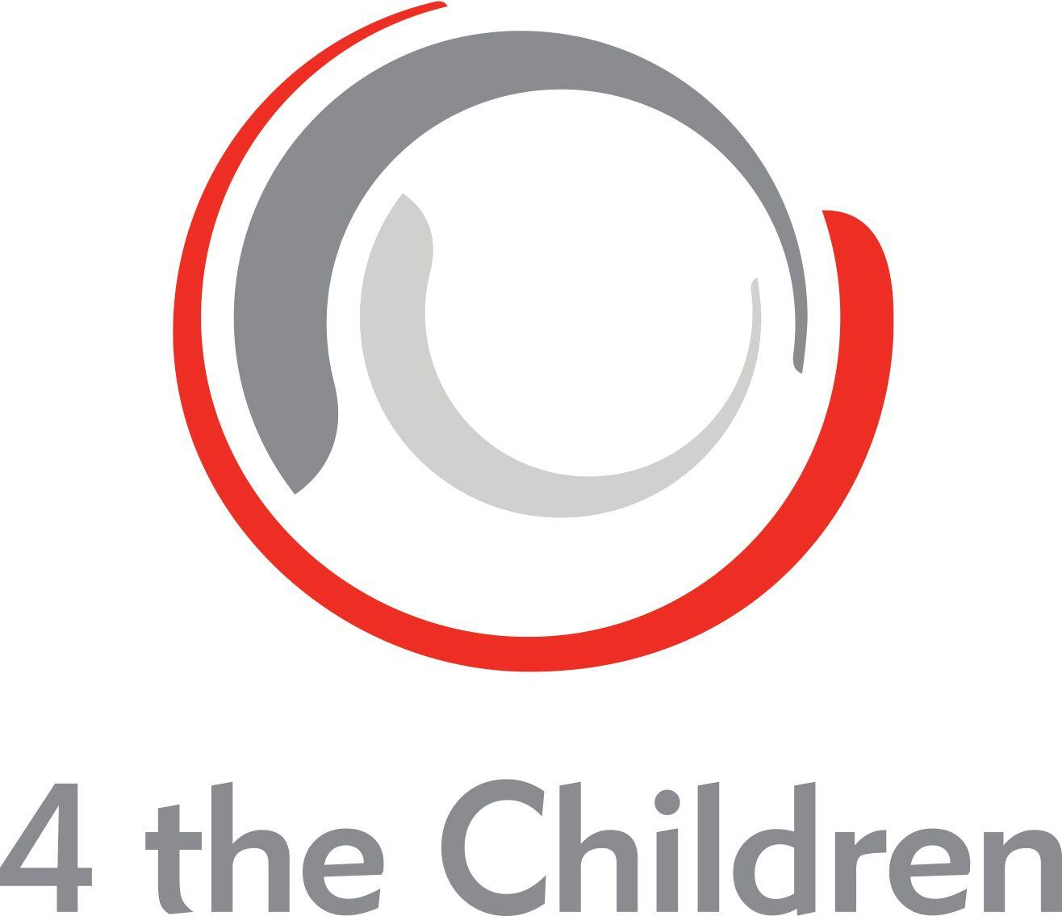  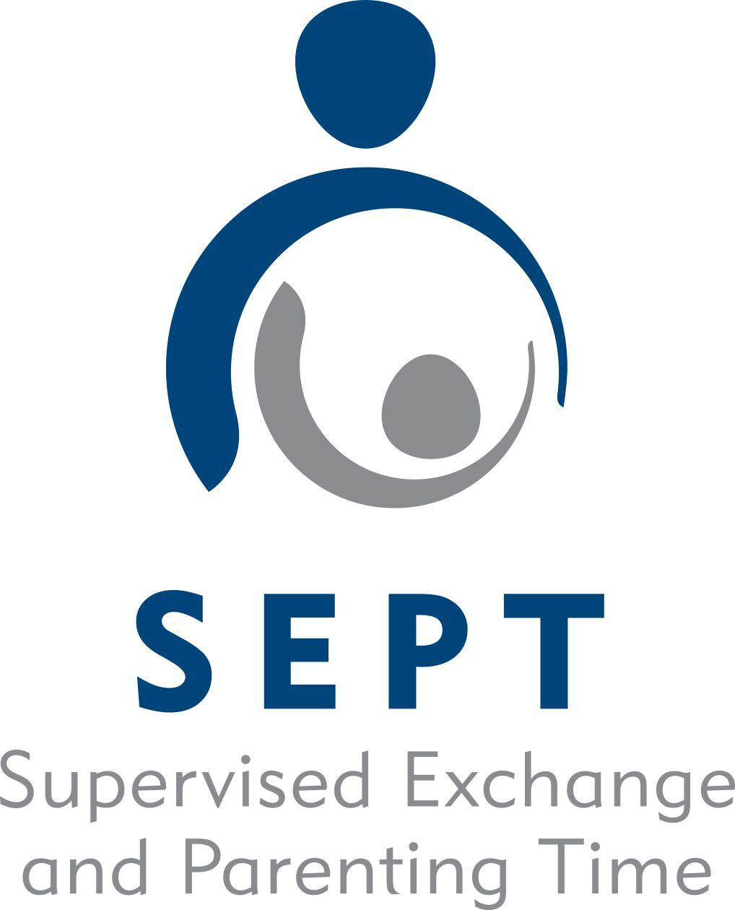 | 4 THE CHILDREN  Supervised Exchange and Parenting Time Program  (SEPT)  Policy: Waiver of Liability

Waiver of Liability

This agreement releases 4 the Children/SEPT from all liability relating to injuries that may occur during supervised visitation or safe exchange. By signing this agreement, I agree to hold 4 the Children/SEPT entirely free from any liability, including financial responsibility for injuries incurred, regardless of whether injuries are caused by negligence.

By signing below I forfeit all right to bring a suit against 4 the Children/SEPT for any reason. In return, I will receive supervised visitation and or supervised exchange. I will also make every effort to obey safety precautions as listed in writing and as explained to me verbally. I will ask for clarification when needed.

I, ____________________________________________, fully understand and agree to the above terms.

__________________________________________ _______________________
(Applicant) (Date)

